Resetting and Updating Leave Balances

Presented by ESC, Region 14

July 2021

Leave balances must be updated at the beginning of each new school year. This will guide you through the process of updating State and Local Leave types so Employee Service Records are correct, as well as Addendums and school Year-To-Date Data.

Every district will update State Leave in the same manner, so the procedures for updating State Leaves should be followed exactly (Board Policy DEC).

Local Leave varies from district to district so we have provided several scenarios. Select the sample that fits your district’s local leave policy.

Before beginning the update process, run a Leave Status Report.

Leave Report

- This step will give you a record of the ending balances for all employees prior to the update process. This will be used in comparing totals from this report to the Mass Update Reports for each Leave Type.

Payroll > Reports > Leave Information Reports,

- Run the Leave Status Report (HRS 7350).
- Select:
- State Sick
- State Personal
- Leave
- Leaves that will accumulate Leave used totals without ever docking employees. Ex: School Business, Jury Duty

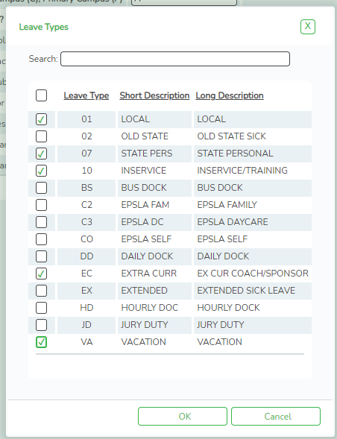
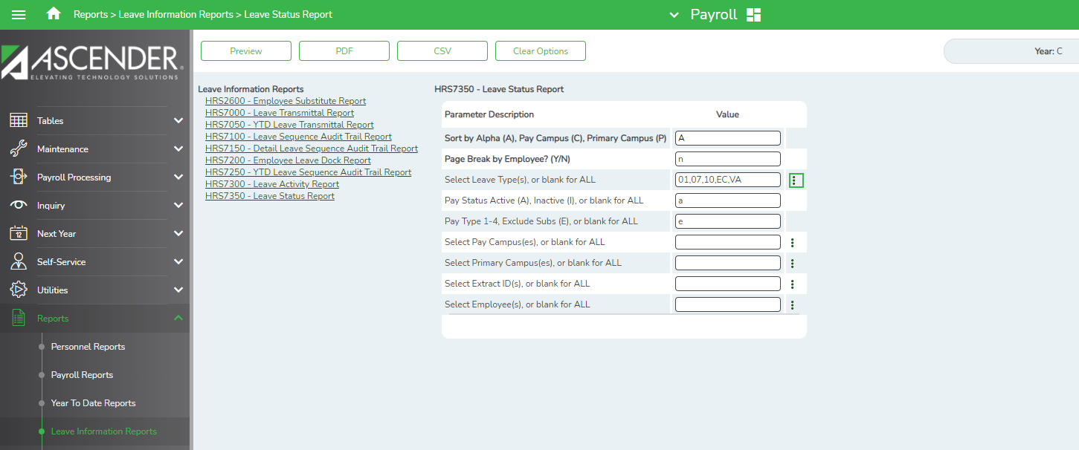

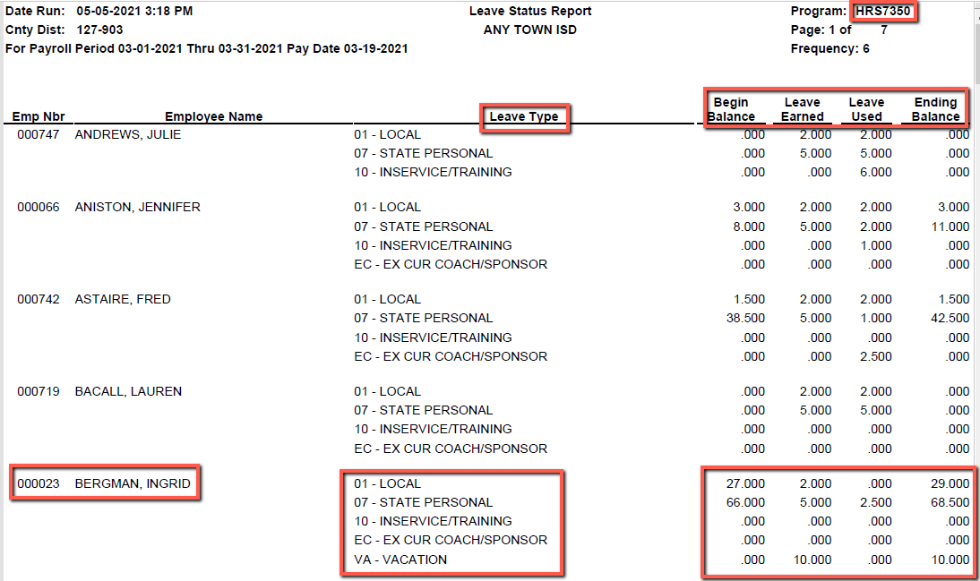

State Personal Leave

- From Payroll > Utilities > Mass Update > Leave tab. Select the radio button to Zero Leave Values for Employees. Check the boxes in the Leave Earned and Leave Used columns for your State Personal Leave code only and Execute. This will cause the ending balance to move the beginning balance, zero the leave earned and the leave used.

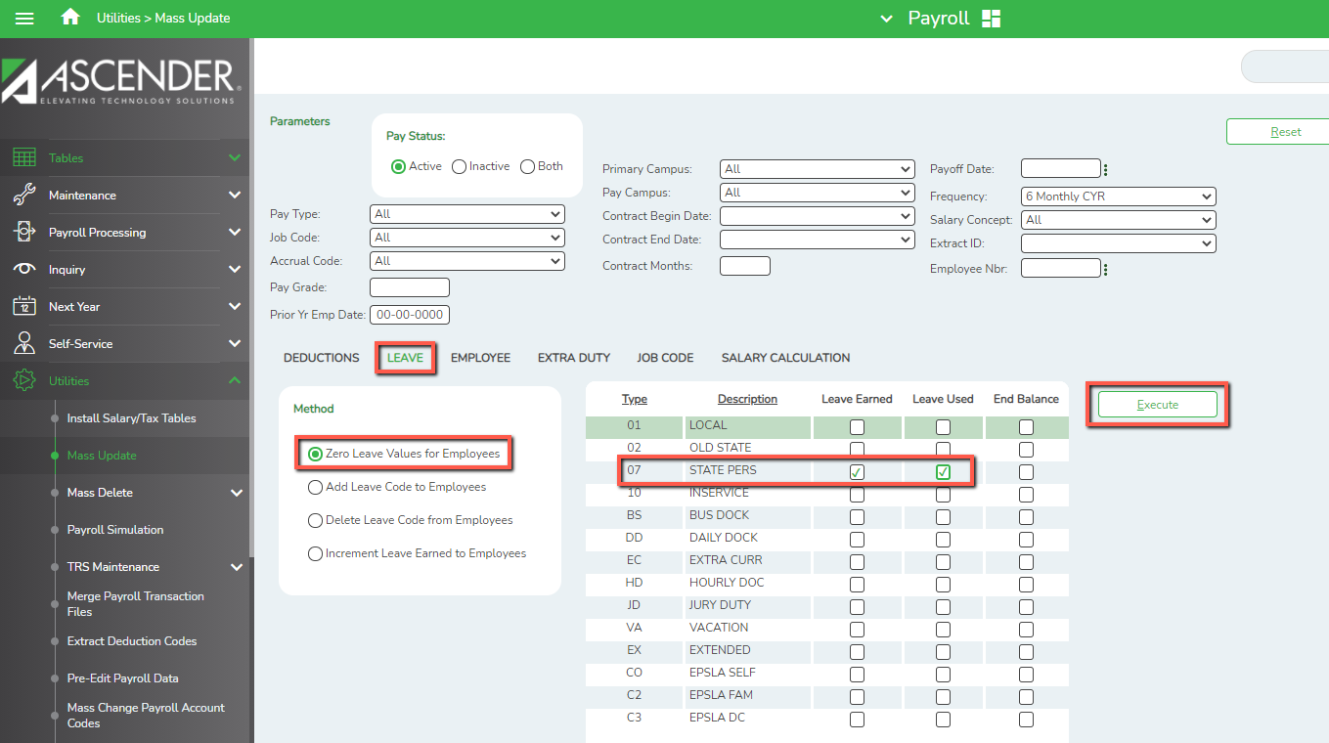

- Select the radio button to Increment Leave Earned to Employees. Check the box in the Leave Earned column for your State Personal Leave code only. Type 5.0 in the Increment box for that leave type and Execute. This will show 5 days of State Personal leave earned for the New school year.

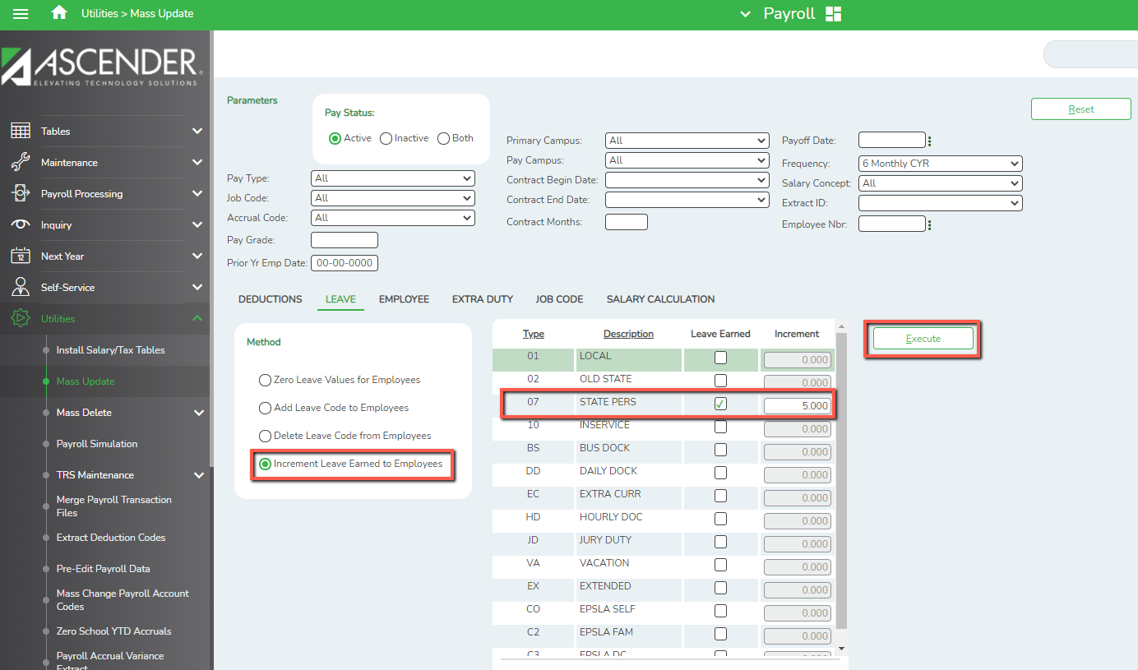

State Sick Leave

- From Payroll > Utilities > Mass Update > Leave tab. Select the radio button to Zero Leave Values for Employees. Check the box in the Leave Used column for your State Sick Leave code only and Execute. This will cause the ending balance to move the beginning balance, and zero the leave used.

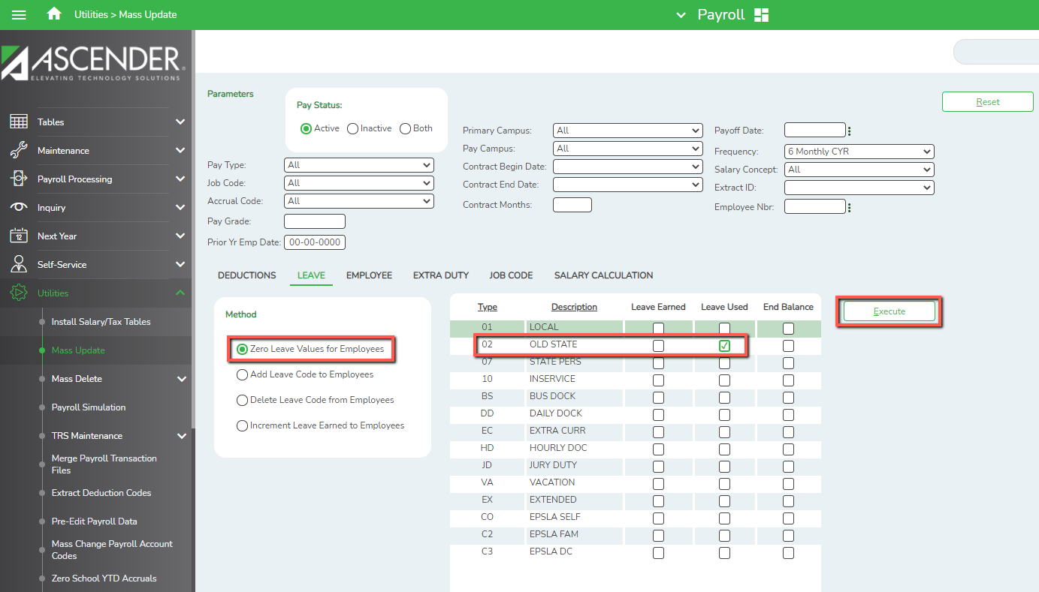

Local Leave

Local Leave policies vary from district to district. Review policy DEC (Local) from your Local Board Policy Manual to determine which scenario describes your policy.
- Local Leave – Use it or Lose it
- Local Leave with a Maximum Balance
- Local Leave – No Maximum Balance

- Local Leave – Use It or Lose It

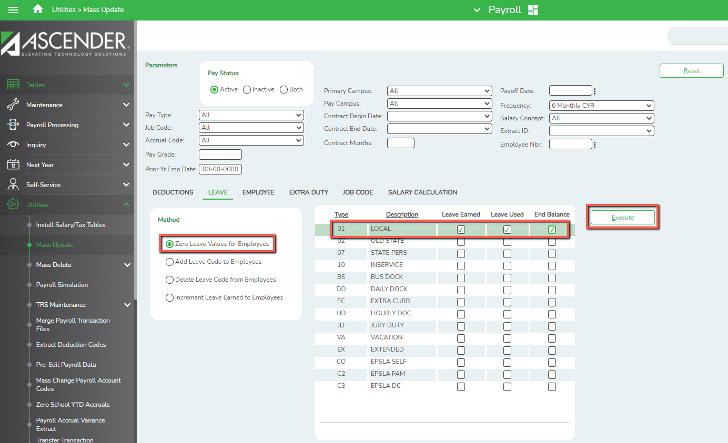
- From Payroll > Utilities > Mass Update, select the Leave tab. Select the radio button to Zero Leave Values for Employees. Check the boxes in the Leave Earned, Leave Used and End Balance columns for your Local Leave code only and Execute. This will zero out the beginning balance, the leave earned, and the leave used.

- Select the radio button to Increment Leave Earned to Employees. Check the box in the Leave Earned column for your Local Leave code only. Type the number of days given according to Local Leave Policy in the Increment box for that leave type and Execute. This will ensure all employees have the allotted Local Leave days to start the New school year.
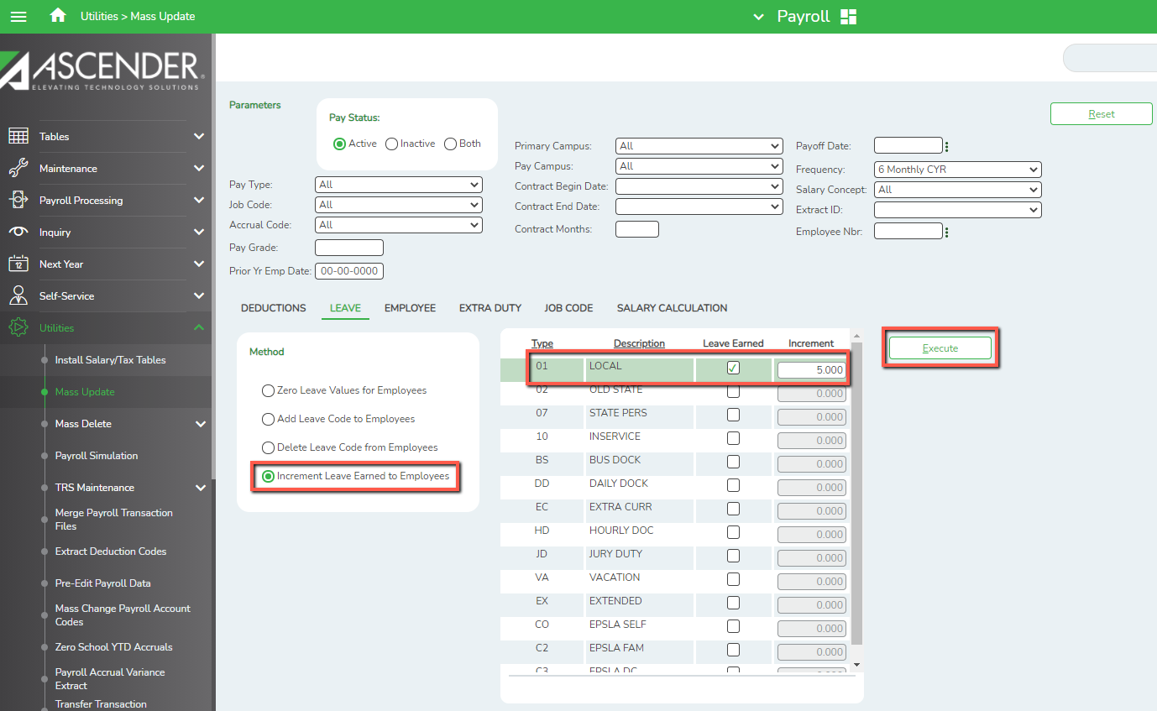

- Local Leave with a Maximum Balance

- From Payroll > Tables > Leave > Leave Type tab. Verify the Local Leave Type displays the appropriate Max Balance according to your Local Leave Policy.

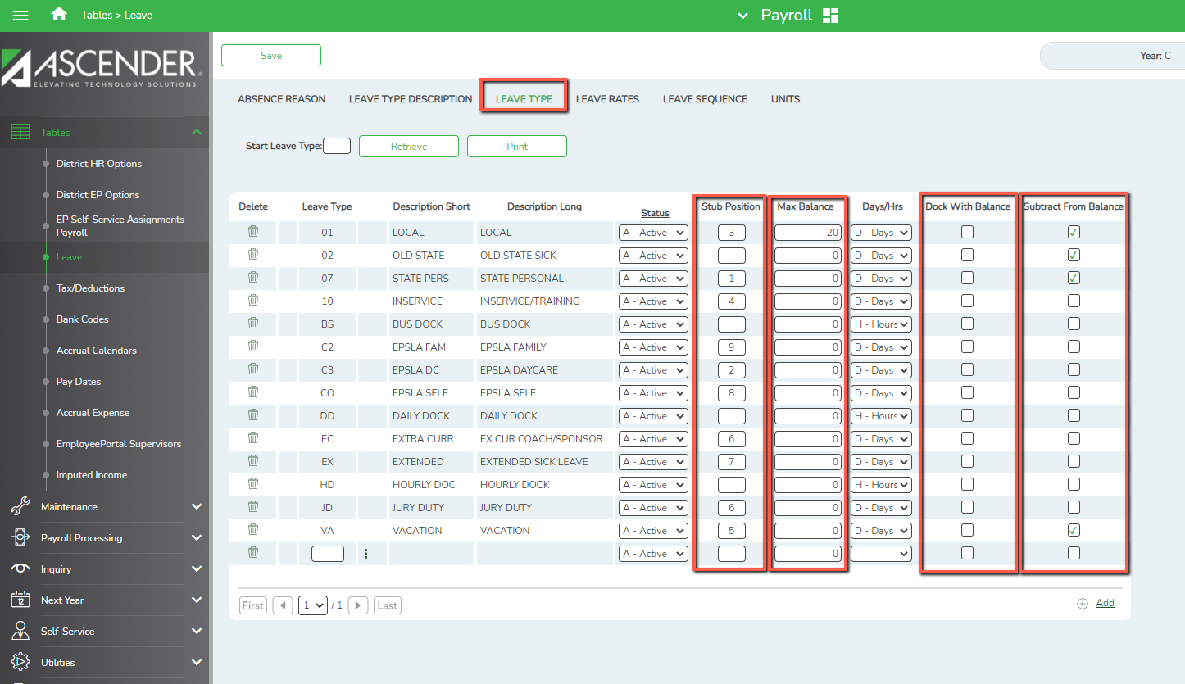

- From Payroll > Utilities > Mass Update > Leave tab. Select the radio button to Zero Leave Values for Employees. Check the boxes in the Leave Earned and Leave Used columns for your Local Leave code only and Execute. This will cause the ending balance to move the beginning balance, zero the leave earned and the leave used.

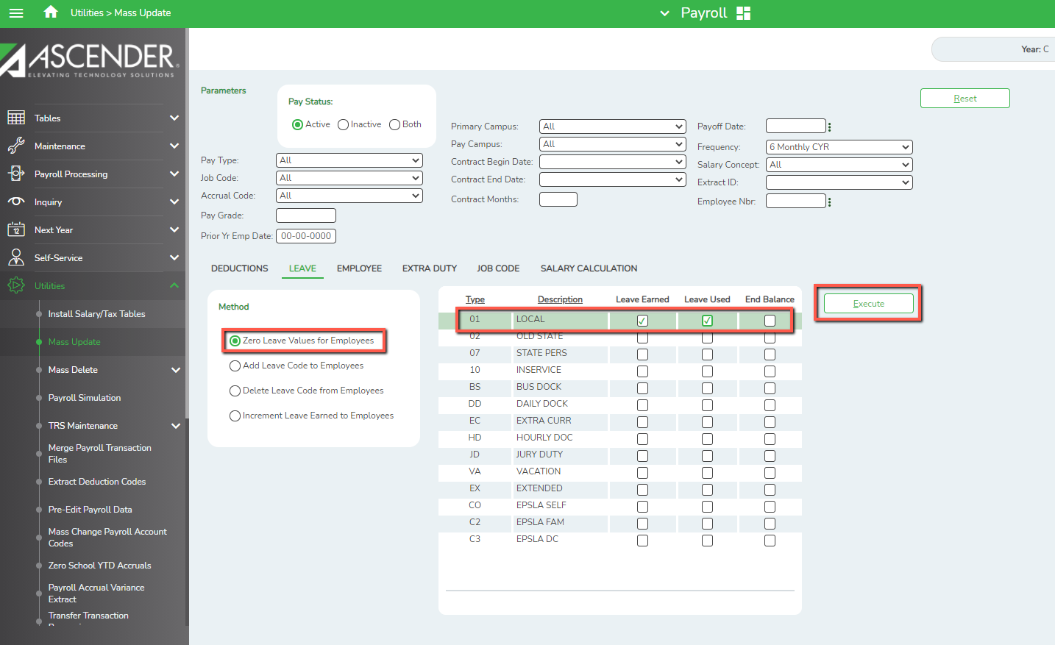

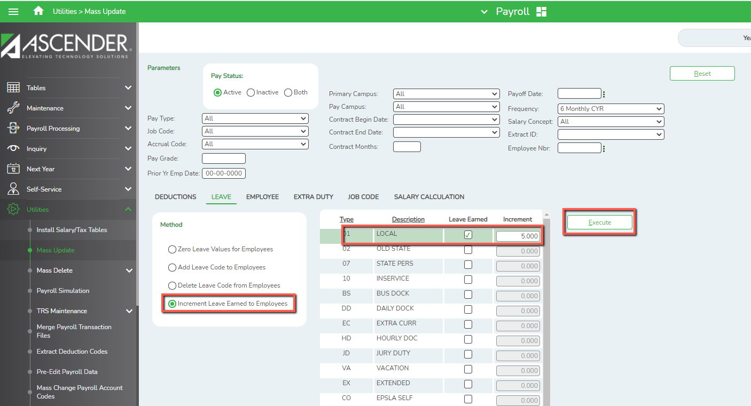
- Select the radio button to Increment Leave Earned to Employees. Check the box in the Leave Earned column for your Local Leave code only. Type number of days given according to Local Leave Policy in the Increment box for that leave type and Execute. This will show the days of Local Leave earned for the New school year. If an employee is near or has reached the maximum number of days allowed in their balance, the number of days earned is adjusted by the system automatically.

- Local Leave With No Maximum Balance

- From Payroll > Utilities > Mass Update > Leave tab. Select the radio button to Zero Leave Values for Employees. Check the boxes in the Leave Earned and Leave Used columns for your Local Leave code only and Execute. This will cause the ending balance to move the beginning balance, zero the leave earned and the leave used.

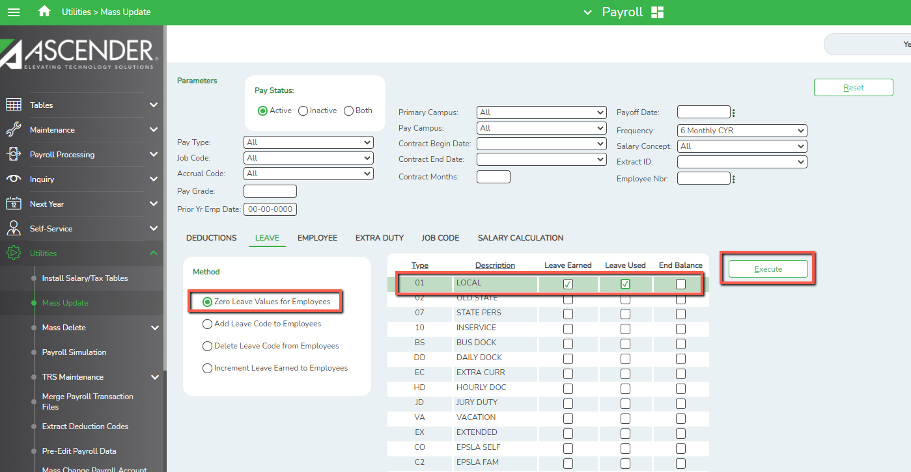

- Select the radio button to Increment Leave Earned to Employees. Check the box in the Leave Earned column for your Local Leave code only. Type number of days given according to Local Leave Policy in the Increment box for that leave type and Execute. This will show the days of Local Leave earned for the New school year.

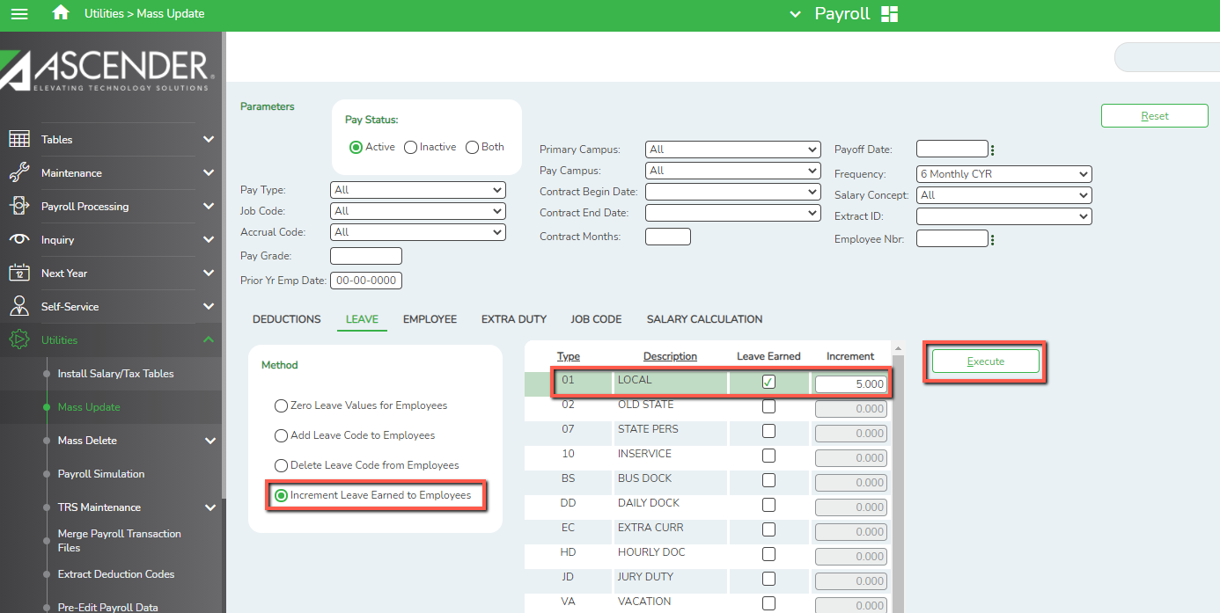
Other Leave Types such as School Business, Jury Duty, etc…

- From Payroll > Utilities > Mass Update > Leave tab. Select the radio button to Zero Leave Values for Employees. Check the box in the Leave Used column for those Leave codes only and Execute. Zeros will display for the Beginning Balance, Leave Earned, Leave Used, and Ending Balance columns for the New school year. These leave types generally accumulate Leave Used totals without ever docking employees for the leave.
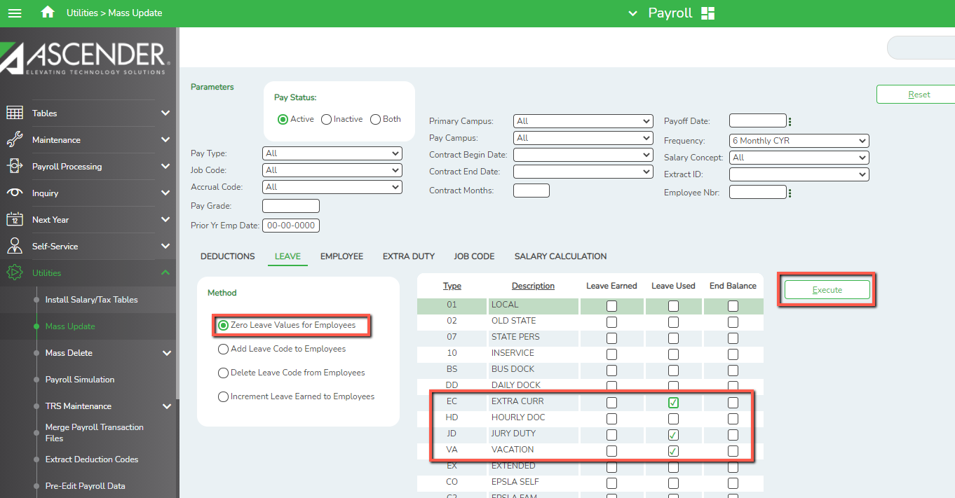

Report Comparison

- From Reports > HR Reports > Leave Information Reports, re-run the Leave Status Report (HRS 7350). Verify all data for all leave types.

